**How to perform single task by multiple threads?**

|  |
| --- |
| If you have to perform single task by many threads, have only one run() method.For example: |

***Program of performing single task by multiple threads***

1. class TestMultitasking1 extends Thread{
2. public void run(){
3. System.out.println("task one");
4. }
5. public static void main(String args[]){
6. TestMultitasking1 t1=new TestMultitasking1();
7. TestMultitasking1 t2=new TestMultitasking1();
8. TestMultitasking1 t3=new TestMultitasking1();
10. t1.start();
11. t2.start();
12. t3.start();
13. }
14. }

[Test it Now](http://www.javatpoint.com/opr/test.jsp?filename=TestMultitasking1)

Output:task one

task one

task one

***Program of performing single task by multiple threads***

1. class TestMultitasking2 implements Runnable{
2. public void run(){
3. System.out.println("task one");
4. }
6. public static void main(String args[]){
7. Thread t1 =new Thread(new TestMultitasking2());//passing annonymous object of TestMultitasking2 class
8. Thread t2 =new Thread(new TestMultitasking2());
10. t1.start();
11. t2.start();
13. }
14. }

[Test it Now](http://www.javatpoint.com/opr/test.jsp?filename=TestMultitasking2)

Output:task one

task one

**Note: Each thread run in a separate callstack.**

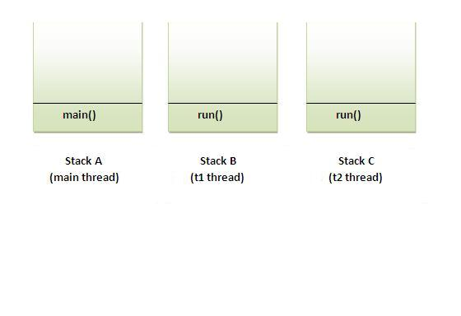

**How to perform multiple tasks by multiple threads (multitasking in multithreading)?**

|  |
| --- |
| If you have to perform multiple tasks by multiple threads,have multiple run() methods.For example: |

***Program of performing two tasks by two threads***

1. class Simple1 extends Thread{
2. public void run(){
3. System.out.println("task one");
4. }
5. }
7. class Simple2 extends Thread{
8. public void run(){
9. System.out.println("task two");
10. }
11. }
13. class TestMultitasking3{
14. public static void main(String args[]){
15. Simple1 t1=new Simple1();
16. Simple2 t2=new Simple2();
18. t1.start();
19. t2.start();
20. }
21. }

Output:task one

task two

**Same example as above by annonymous class that extends Thread class:**

***Program of performing two tasks by two threads***

1. class TestMultitasking4{
2. public static void main(String args[]){
3. Thread t1=new Thread(){
4. public void run(){
5. System.out.println("task one");
6. }
7. };
8. Thread t2=new Thread(){
9. public void run(){
10. System.out.println("task two");
11. }
12. };

15. t1.start();
16. t2.start();
17. }
18. }

Output:task one

task two

**Same example as above by annonymous class that implements Runnable interface:**

***Program of performing two tasks by two threads***

1. class TestMultitasking5{
2. public static void main(String args[]){
3. Runnable r1=new Runnable(){
4. public void run(){
5. System.out.println("task one");
6. }
7. };
9. Runnable r2=new Runnable(){
10. public void run(){
11. System.out.println("task two");
12. }
13. };
15. Thread t1=new Thread(r1);
16. Thread t2=new Thread(r2);
18. t1.start();
19. t2.start();
20. }
21. }

Output:task one

task two